|  |
| --- |
| Importing Data From an External Source |
|  |

1. Download the [Students](http://functionx.com/sqlserver/Students.txt) text file and save it to your hard drive
2. In the SQL Server Management Studio, right-click the Databases node and click New Database...
3. Type **ROSH** and press Enter
4. In the Object Explorer, right-click ROSH, position the mouse on **Tasks** and click **Import Data**
5. On the first page of the wizard, click Next
6. On the second page, click the arrow of the Data Source combo box and select Flat File Source
7. On the right side of File Name, click the Browse button
8. Locate and select the Students.txt file you had saved  
      
   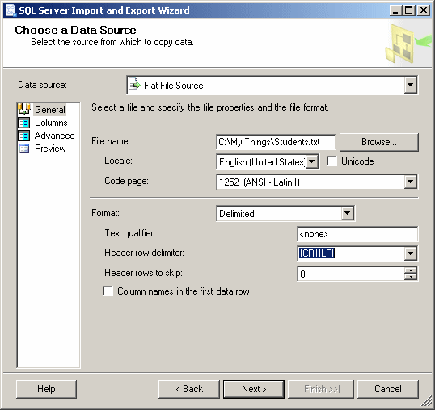
9. Under Data Source, click Advanced
10. As Column is selected, in the right list, click Name and type StudentID
11. In the middle list, click each column and change its Name in the right column as follows:

|  |  |
| --- | --- |
| **Column** | **Name** |
| Column0 | StudentID |
| Column1 | FirstName |
| Column2 | LastName |
| Column3 | DateOfBirth |
| Column4 | Gender |
| Column5 | Address |
| Column6 | City |
| Column7 | State |
| Column8 | ZIPCode |
| Column9 | HomePhone |
| Column10 | EmailAddress |
| Column11 | ParentsNames |
| Column12 | SPHome |
| Column13 | EmrgName |
| Column14 | EmrgPhone |

1. 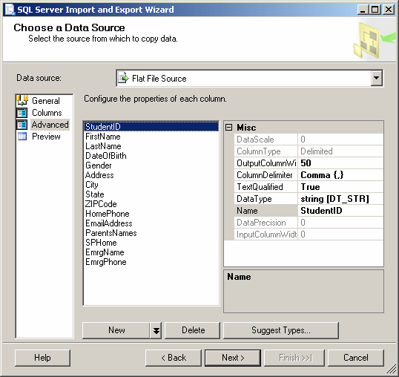
2. To see the list of columns, under Data Source, click Columns  
      
   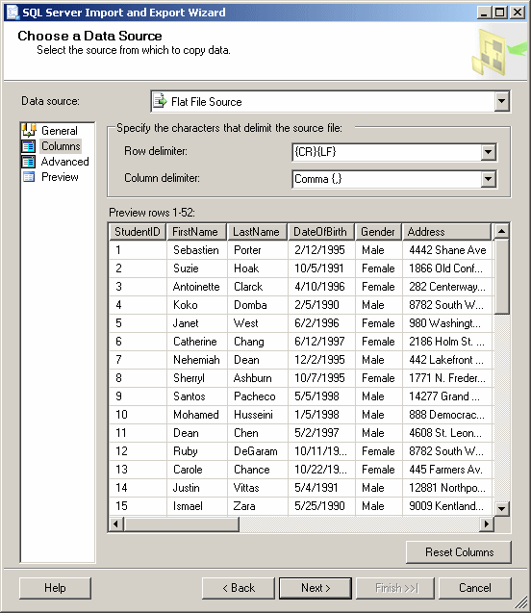
3. Click Next 4 times
4. Click Finish  
      
   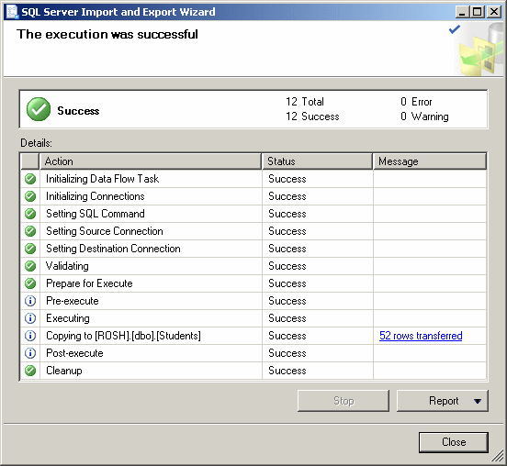
5. Click Close
6. Back in the Object Explorer, expand the ROSH and its Tables nodes.  
   Right-click Students and click Design
7. As the **StudentID** field is selected, press Tab and change its data type to **int**
8. Press F6 and expand Identity Specification. Double-click **(Is Identity)** to set its value to Yes
9. Change the other columns as follows:  
      
   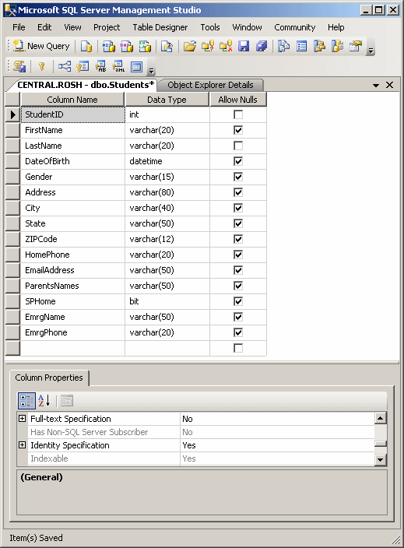
10. To save the table, click the Save button on the Standard toolbar:  
       
    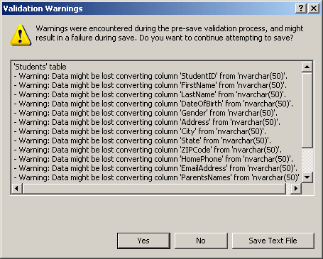
11. When a Validation Warnings dialog box presents a few warnings, click Yes
12. Close the table
13. To view data stored on the table, in the Object Explorer, right-click dbo.Students and click Open Table